**VISVESVARAYA TECHNOLOGICAL UNIVERSITY**

**“JnanaSangama”,Belagavi-590018, Karnataka, India**



Synopsis of the Proposed Project Report on

“**IOT BASED AUTOMATIC AND MANUAL TRAFFIC LIGHT CONTROL SYSTEM”**

*Submitted in partial fulfilment of the requirements for the award of degree of*

***BACHELOR OF ENGINEERING***

IN

**Electronics & Communication Engineering**

*Submitted by*

HARISH GOWDA T 1RF19EC010

NANDAGOKUL P 1RF19EC020

PUNYASHREE G 1RF19EC024

DEEPAK A KAGGODI 1RF19EC049

**Under the guidance of**

Prof. NAGESH M

Assistant Professor, Dept. of ECE, RVITM



**RV INSTITUTE OF TECHNOLOGY AND MANAGEMENT®**

**(Chaitanya Layout, JP Nagar 8th Phase, Kothanur, Bengaluru-560076)**

**2022-2023**

**CONTENTS**

1. ABSTRACT
2. MOTIVATION
3. LITERATURE REVIEW
4. OBJECTIVES
5. METHODOLOGY
6. FLOWCHART
7. COMPONENTS REQUIRED
8. EXPECTED OUTCOME
9. REFERENCES

**ABSTRACT**

Over the years, there has been a sudden increase in the number of vehicles on the road. Traffic congestion is a growing problem everyone faces in their daily life. Manual control of traffic by traffic police has not proved to be efficient. Also the predefined set time for the signal at all circumstances (low and high traffic density) has not solved this problem.

A model to effectively solve the above-mentioned problems by using Internet of Things (IoT) is proposed. We use cloud for internet based computing, where different services such as server, storage and application are delivered for traffic management. A network of sensors is used to track the number of vehicles and the traffic congestion at the intersections on a road and rerouting will be done on the basis of the traffic density on the lanes of a road. . It also uses IR sensors that indicate traffic congestion at intersections (crossroads). The programming is done using Arduino IDE. The data is monitored on device and the image is displayed on the app along with time and date of the violation incident.

This approach to traffic congestion is expected to significantly improve traffic congestion in order to predict traffic congestion and find a solution. It can also provide information about traffic violations and thus, help monitor and control effectively. Moreover, supervised learning methodologies are proposedthat would help in determining the standard of roads, estimating overall traffic flow, calculating average speed of distinct vehicle types on a road and analyzing the travel path of a vehicle.

**MOTIVATION**

In 2014, 54% of the total global population was urban residents. The prediction was a growth of nearly 2% each year leading to more pressure on the transportation system of cities. Additionally, the high cost of accommodation in business districts lead to urban employees living far away from their place of work/education and therefore having to commute back and forth between their place of residence and their place of work.More vehicles moving need to be accommodated over a fixed number of roads and transportation infrastructure.Often, when dealing with increased traffic, the reaction is just widen the lanes or increase the road levels. However, cities should be making their streets run smarter instead of just making them bigger or building more roads. This leads to the proposed system which will use sensors to switch on green light by detecting vehicle overload.

**LITERATURE REVIEW**

|  |  |  |
| --- | --- | --- |
| AUTHOR | PROS | CONS |
| Hosur, proposed a framework using IoT technologies that evaluate the traffic density via IR sensors to achieve dynamic timings for the traffic light,  2019 | In their proposed system, they considered some threshold distance when the sensor detects any vehicle within this distance using IoT technologies. When other roads are empty of vehicles, it switches to a green light. The IoT can help to access components from far places, and their proposed system is beneficial for non-peak hours and saves power during non-peak hours. | The disadvantage of their work is that they do not consider peak hours because most vehicles will only be present during these rush hours, which is an essential factor for traffic system control. |
| Liang, changed the traffic light signal durations according to the discrete values of the actions, 2019 | They collected the data from sensors and divided the whole intersection into small grids | The information received from these sensors is difficult to process to find the duration of green and red lights. Such algorithms have low performance in peak traffic conditions, and the main reason is to ignore the impact of the current phase time on future traffic. |

|  |  |  |
| --- | --- | --- |
| AUTHOR | PROS | CONS |
| Lillicrap, extended the idea of Q-learning to the continuous action domain,  2015 | Proposed algorithm was able to discover policies whose performance was competitive with predefined scheduling algorithms due to the dynamics of the environment. | The convergence of the training process is complicated, which is an important factor for continuous traffic flow. |
| Hongwei Ge, proposed a MARL algorithm for traffic signal control,  2021 | They improved the cooperation strategies of the algorithm, their focus in this work was to increase the capability of agents to learn. They showed the robustness of their algorithm. | According to the research presented, cases attempted to control the traffic signals with SCATS which is an adaptive traffic signal control, but it cannot do it in dynamic conditions. |

**OBJECTIVES**

* The objective of the system is to adjust the traffic light timings as traffic density on a particular road.
* If a traffic violation is done at a red light, then the control unit will receive the message that “Signal is crossed “and at what time.

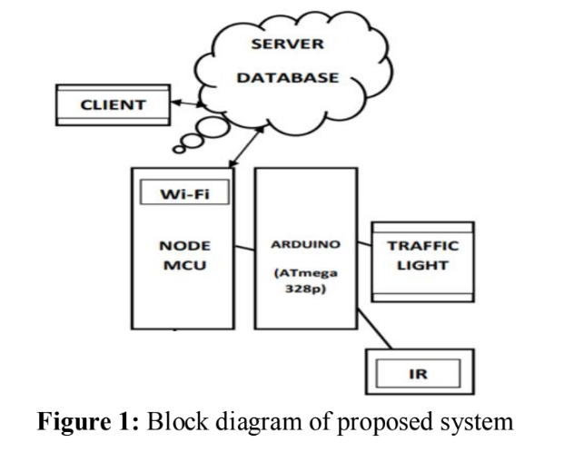

**METHODOLOGY**

* The Arduino will receive information about the traffic density using IR sensors. Under Normal traffic conditions, the time duration of each traffic light ( Red, yellow, green ) is two seconds.
* Depending on the traffic movement received from the IR sensors, the data will be managed dynamically to avoid traffic congestion.
* In case of traffic congestion, the IR sensors detect the presence of the vehicle and send the density information to Arduino UNO which alters the duration of green traffic light of the particular lane from two seconds to six seconds.
* When there is no traffic violation, the density management is done as per the specified flow, i.e. two seconds each in case the traffic density decreases to normal and remains six seconds if heavy traffic still persists.
* In case of traffic violation, i.e. if a vehicle jumps the red light, the data reaches the ThingSpeak Channel.
* Further, the control unit will receive the message that “Signal is crossed “ and at what time.
* The mobile app displays the date and time of violation along with the message. This can be accessed by the traffic administrator from any smart device such as laptop, desktop, smart phones, tablets, etc.

**FLOW CHART**

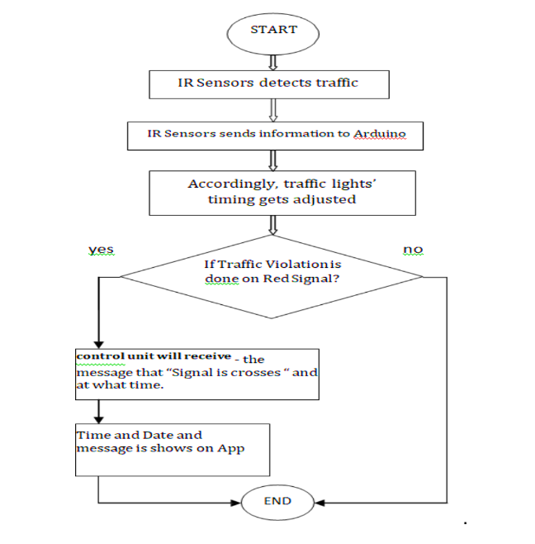

**COMPONENTS REQUIRED**

* Arduino - Arduino is an open-source project that created microcontroller-based kits for building digital device and interactive objects that can sense and control physical devices.
* ESP8266 NodeMCU - NodeMCU is an open-source firmware and development kit that helps to prototype and build IoT products. It includes firmware that runs on the ESP8266 Wi-Fi SoC from Espressif Systems, and hardware which is based on the ESP-12 module.
* ThingSpeak - ThingSpeak is an IoT application platform providing various services exclusively targeted forbuilding IoT applications. It offers capabilities like real-time data collection, visualizing the collected data in theform of charts and widgets , ability to create plugins and apps for collaborating with web services, socialnetwork and other APIs.

**Expected Outcome**

Although the prototype model worked very efficiently with remarkable outputs, the real-time situation is going to be way more demanding and challenging. Few of the challenges that should be taken into consideration are listed as follows

• Low range IR sensors may not be suitable for long range traffic signalling systems. We may convert to ultrasound or radar techniques for big scale set-ups.

• Periodic checking of the precision and accuracy is a must for efficient operation of this model prototype.

• Next is the influence of drift signals that may differ the reading of sensory receptors and lead to conveying any false information to the microcontroller.

This will act as a feed forward system making the signalling system even more smooth and congestion free. We will also update this system with modern technologies so that when a vehicle tries to move even during a red signal it will turn on an alarm in the form of an alert to warn the driver of the vehicle.

**REFERENCES**

[1] Aaron Don M. Africa, Francis Xavier Asuncion, Janos Lance Tiberio, Raymund Miguel Francisco A.Munchua “Sensor-based Traffic Control Network with Neural Network Based Control System”-IJATCSE Vol 8 (August 2019).

[2] Mr. Bilal Ghazal, Mr. Khaled ElKhatib“Smart Traffic Light Control System”- IJERT (April 2016)

[3] Mr. Shubhamsahu, Mr. Depanjampaul, Mr.Senthilmurgan“Density based traffic control usingIR sensors”- IRJET (June 2019).

[4] Mr. Piyushmahajan, Ms. punamkumari, Mr. HPS kang“Design and implementation of portable traffic system”- IJRTER (2017).

[5] Mr. Tenepallikalyansaimanikantachari, Mr. Sai tejatutika“Density based traffic control signalinusing ir sensor”- Philpapers (2019).